# TITLE PAGE

**DESIGN AND IMPLEMENTATION OF A STUDENT ELECTRONIC PORTAL WITH RESULT PIN (CASE STUDY OF STAFF DEMONSTRATION SCHOOL, FEDERAL POLYTECHNIC, MUBI)**

**BY**

**COMFORT YUNANA**

**ST/CS/ND/21/008**

**DEPARTMENT OF COMPUTER SCIENCE,**

**SCHOOL OF SCIENCE AND TECHNOLOGY,**

**FEDERAL POLYTECHNIC, MUBI, ADAMAWA STATE.**

**IN PARTIAL FULFILMENT OF THE REQUIREMENT FOR THE AWARD OF NATIONAL DIPLOMA (ND) IN COMPUTER SCIENCE.**

**SEPTEMBER, 2023**

# DECLARATION

I hereby declare that the work in this project titled “**Design and Implementation of a Student Electronic Portal with Result PIN (Case Study of Staff Demonstration School, Federal Polytechnic, Mubi)”** was performed by me under the supervision of Mal. Sintali M. Garba. The information derived from literatures has been duly acknowledged in the text and a list of references provided. The work embodied in this project is original and had not been submitted in part or in full for any other diploma or certificate of this or any other institution.

COMFORT YUNANA ___________________

(ST/CS/ND/18/018) Signature/Date

# CERTIFICATION

This project work titled “**Design and Implementation of a Student Electronic Portal with Result PIN (Case Study of Staff Demonstration School, Federal Polytechnic, Mubi)”** meets the regulations governing the award of National Diploma (ND) in Computer Science, Federal Polytechnic Mubi, Adamawa State

Mal. Sintali M. Garba __________________

(Project Supervisor) Sign/Date

Mallam Adamu Mubi Garba __________________

(Head of Department) Sign/Date

Abdulrahaman Saidu _________________

(External Examiner) Sign/Date

# DEDICATION

I dedicate this project work to Almighty God for granting me the ability to accomplish this work successfully.

# ACKNOWLEDGEMENTS

I want to acknowledge Almighty God for his infinite mercy and protection throughout my academic activities. And for the understanding in achieving my academic success.

I also acknowledge the Head of Department Computer Science Mallam Adamu Garba Mubi for his moral encouragement throughout my period of study.

I also recognize my Supervisor Mal. Sintali M. Garba, who took time, despite his busy schedule to direct and guide me throughout this research work.

I also acknowledge all Staff of Computer Science Department for their support and encouragement and the knowledge they’ve impacted on me throughout my studies.

I also want to appreciate my lovely mum for her love and care and for giving me the opportunity to be trained and achieve my dreams.

Finally, I appreciate the efforts of my Uncles, for their encouragement and support throughout the course of my study. And also my friends and relatives, course mates and all well-wishers. I love you all, may the Almighty God bless you abundantly, Amen.

**TABLE OF CONTENTS**

TITLE PAGE i

DECLARATION ii

CERTIFICATION iii

DEDICATION iv

ACKNOWLEDGEMENTS v

LIST OF FIGURES viii

LIST OF TABLES ix

ABSTRACT x

CHAPTER ONE i

INTRODUCTION 1

1.1 Background to the study 1

1.2 Statement of the problem 2

1.3 Purpose of the study 3

1.4 Significance of study 3

1.5 Scope of the study 4

1.6 Limitations of the study **Error! Bookmark not defined.**

1.7 Definition of operational terms 4

CHAPTER TWO 6

LITERATURE REVIEW 6

2.1 Introduction 6

2.2 Review of related literatures 6

2.3 What is a Web-Portal 7

2.4 Effectiveness of E-portal 11

2.5 E-Portal Satisfaction 13

2.6 Major functions of portal 14

CHAPTER THREE 15

SYSTEM ANALYSIS AND DESIGN 15

3.1 Introduction 15

3.2 Disadvantages of the existing system 15

3.3 Advantages of the proposed system 15

3.4 The proposed method **Error! Bookmark not defined.**

3.5 Methods of data collection 17

3.6 System design 17

Table 3.1: access 18

3.7 System requirement specification **Error! Bookmark not defined.**

CHAPTER FOUR 25

RESULTS AND DISCUSSION 25

4.1 Introduction 25

4.2 Results 25

4.3 Discussion 31

4.4 User manual 32

CHAPTER FIVE 34

SUMMARY, CONCLUSION AND RECOMMENDATION 34

5.1 Summary 34

5.2 Conclusion 34

5.3 Recommendations 34

5.4 Contribution to Knowledge 34

5.5 Area for further work 34

REFERENCES 35

APPENDIX A 38

APPENDIX B 45

# LIST OF FIGURES

Figure 3.1: UML class diagram - - - - - - 25

Figure 3.2: Database entity relationship diagram - - - 31

Figure 3.3: Login interface - - - - - - 31

Figure 3.4: Create Profile interface - - - - - 32

Figure 3.5: Complete Registration interface - - - - - 33

Figure 4.1: Welcome interface - - - - - - 35

Figure 4.2: Home page interface - - - - - - 35

Figure 4.3: Login page interface - - - - - - 36

Figure 4.4: Signup page interface - - - - - - 36

Figure 4.5: Edit profile page interface - - - - - 37

Figure 4.6: Create announcement interface - - - - - 37

Figure 4.7: Announcement interface - - - - - - 38

Figure 4.8: Upload result interface - - - - - - 38

Figure 4.9: Publish result interface - - - - - - 39

Figure 4.10: Student registration slip interface - - - - 40

Figure 4.11: Staff dashboard interface - - - - - 41

Figure 4.12: Student dashboard interface - - - - - 41

# LIST OF TABLES

Table 3.1: access - - - - - - - 26

Table 3.2: Administrative - - - - - - 26

Table 3.3: Announcement - - - - - - 26

Table 3.4: Classes - - - - - - - 26

Table 3.5: Current Session - - - - - - 27

Table 3.6: Result - - - - - - - 27

Table 3.7: Students - - - - - - - 28

Table 3.8: Subjects - - - - - - - 29

Table 3.9: Teachers - - - - - - - 29

Table 3.10: Users - - - - - - - 30

# **ABSTRACT**

The advent of information technology has brought about a huge effect on the entire education system and also has made the student to shift from manual systems to computerised systems. Most of the system that involves manual work has been automated efficiently. Student registration process in Federal Polytechnic, Mubi Staff Secondary School involves filling registration forms manually, getting it signed by respective Management and then getting the documents, then the registration forms are submitted in the Administrative office, also the existing system involves manual process of generating results and given to students which is liable to forgery. This process is very laborious and time consuming. A Student E-Portal is therefore developed to simplify the manual procedure. The methodology involves using PHP, Apache and MySQL while front-end is designed with PHP, the back-end is managed with MySQL. The system is more secured and user-friendly. The researcher also makes recommendation that the system be implemented by Federal Polytechnic, Mubi Staff Secondary School and other secondary schools as well. Also, further researcher should be made to include online payment as the new system is limited in that aspect.

# CHAPTER ONE

# INTRODUCTION

## 1.1 Background to the study

Education is one of the key sectors that have been transformed by the digital revolution, especially the internet. Most institutions of learning now carry out many of their academic and administrative functions including student admission, student registration, staff recruitment, program advertisement, course delivery and general administration via the university electronic portals or web-portals (Lim, 2014). According to. Worjtkowski and Major (2015), a web portal is a collection of technologies that ‘function together as a presentation tool to securely display corporate data, add to it information on the Internet, and customize and simplify access to that information’.

Educational portals have become major communication platform between universities and their students, prospective students, parents, faculty, staff, alumni and donors (Pierece, 2015; Hasan, 2013). They. enable students to register online, upload and download course materials, access grades and campus bulletins, use email and search engines. Other capabilities of e-portals include unified login, personalization, document management, personal and, group calendars, to do list and system security (Sharma & Gupta, 2015; Abuhamdieh & Sehwail, 2017).

Most academic institutions in Nigeria have invested substantially in creating institutional e-portals in order to take advantage of the possibilities that e-portals technology offers. The widespread adoption of the e-portal technology by academic institutions has instigated research into the usability of web portals. This is due to the fact that most web site design efforts are focused on technology and business objectives rather than user needs. Usability is the extent to which users are able to use a product to achieve the desired goals with effectiveness, efficiency and satisfaction. It connotes understandability, learnability, operability and attractiveness (International Standard Organization, 2018). Usability assessment serves as feedback mechanism and can be used to enhance information systems to better meet user’s needs. Since students are the principal users of educational e-portals, this study was conducted to understand undergraduate students’ assessment of the usability of e-portals in selected private universities in south-west Nigeria. Portals build on the same technology used for Web sites, but enhance the functionality and flexibility to cater for the demands of specific classes of user. According to Gerd (2015), “Portals are a special breed of external or internal Websites offering a blend of information, applications and services. This implies that portals always have more than just information to offer, as many Websites do”.

According to Allan (2014), “Put simply a portal is a presentation layer which aggregates, integrates, personalizes and presents information, transactions and applications to the user according to their role and preferences”. Portal and website is definitely different in term of their definition where portal is a gateway to access information meanwhile, website represent the basic delivery of online content. There is chemistry between portal and website where portal build on the same technology used for web site, but enhance the functionality and flexibility to cater for the demands of specific classes of user.

From both perceptions portal can be concluded as a gateway to web access which users can locate all the web content they commonly need which required personalization, search, channels, links, and customization base on role and workflow.

According to Masrek (2017), “Traditionally, a portal denotes a gate, a door, or entrance. In the context of the World Wide Web, it is the next logical step in the evolution to a digital culture”. Formerly, portals are defined as search engines where it offers a full text index of document content. Today’s Internet portals offer a more structured, navigable interface compare to Internet search engines. Internet portal is more focused on better delivery of specific information among a group with the same interest.

## 1.2 Problem Statement

In present system all work is done on papers manually. The attendance in the present system is maintained in register books. The semester marks and mid sectional exam marks are maintained in papers. The student cannot access his/her academic details at all time and moreover searching for his marks in those set of papers is a time consuming activity.

Retrieving detail and accurate information is very critical especially for public and people that are involved in an organization. The registration problem due to some manual means of operations which easily lead to misplacement or loss of student information and documents.

The manual pre-assessment, of student registration system is very slow and consumes a lot of time which causes the delay in completing the entire enrolment process. Consume time and human effort due to long queue in the process of paying money in the bank and registration processes.

Due to manual means of generating report, such report can easily be misplaced or loss. The outcomes from this study will assist the university to know whether or not the problems of manual handling of students’ registration and mismanagement records have been overcome. The level of acceptance and use of e-registration by the students of the university that ‘will be unraveled in this study will provide a framework for the improvement of e-registration at the university from which other universities in the country can copy to improve their own e-registration exercise.

The problems so discussed above gave room for the necessity of developing a system that will help Poly Staff Secondary School in handling these various problems so identified.

## 1.3 Aim and Objectives

Owing to the difficulties experienced, retrieving detail and accurate information is very critical especially for public institutions, this project is aimed at designing and implementing a system for Poly Staff Secondary School. The objectives of the study are as follows:

1. To design an automated student database management system in place of papers.
2. To design a system that will generate funds for the institution by creating Result Checking PINs.
3. To create an online Student Portal which provides a pre-assessment module that allows subjects verification to the students when login on the website.
4. To design a system for Online Result Checking System for both Students and Parents of Poly Staff School.

## 1.4 Significance of study

The student portal makes available one source of information to be integrated and accessed from a single search source, thereby reducing time, complexity and cost of obtaining information over various sources and also to give full details of individual students in the school.

In addition, the student portal can also automatically evaluate and showcase the report of subjects of the students.

Also, the project will create a platform for the checking and printing of students’ result which will contribute to the school management financially through the sales of PINs for result checking and create room for parents to access and review their children/wards academic performance.

Through this system, both the students and management will be able to use the Student Portal effectively for their online registration process especially for registering their personal information, subject registration etc.

The future researchers could gain knowledge from the study on the benefits, advantages, and disadvantages, the impact of developing web portals which they may apply to their research in the future. By improving on the portal in such a way that is being connected with Interswitch whereby students will be able to make any necessary payment through the website, payment like school fee, craft fee, and sports fee and so on.

## 1.5 Scope of the study

The proposed system is targeted for the effective and easy use by Students, Parents and the Management of Federal Polytechnic Staff Secondary School, Mubi.

The scope of the study includes Registration of Students, Uploading and Checking of Students result and querying of the database for the necessary information for administrative purposes.

## 1.6 Definition of operational terms

**E-portal:** Rao (2013), defined an enterprise portal is a web interface for users of enterprise applications. Enterprise portals provide access to enterprise information such as corporate database, application (including web applications).

**PHP**: Normally used for increased functionality on a website or to work with a database. It works in conjunction with html and html variants and allows for functions to be run from the server rather than the visitor’s browser (Brayand, 2014).

**Portal**: A portal is a presentation layer which aggregates, integrates, personalizes and presents information, transactions and applications to the user according to their role and preferences (Brayand, 2014).

**Portlets**: They are small applications that provide interaction with different external data sources. They are also known as gadgets web parts or web nodules. Portlets are regions that display data from different sources like websites and application (Adepoju and Osofisan, 2018).

**Responsive design:** A website that adjusts to the screen it is being viewed on, whether desktop, mobile or smart phone. Media queries are used to figure out the resolution of the device the website is being displayed on. Then, flexible images, fluid grids and the site menu are adjusted to fit the screen (Brayand, 2014).

**User Personalisation:** Enables the end-user to take customisation one step further, namely to subscribe and unsubscribe to channels and alerts, set application parameters, create and edit profiles, add or remove links, and many more (Adepoju and Osofisan, 2018).

**Vertical Portals:** Provide access to a variety of information and services about a particular area of interest. For example, http:/Avww.wine.com is a vertical portal. Such portals offer information and services customized for niche audiences (e.g., undergraduates, faculty) (Boye (2015).

**Web Portals:** According to Babie (2014), a web system that provides the functions and features to authenticate and identify the users and provide them with easy intuitive personalized and user-customizable web-interface for facilitating access to information and services that are of primary relevance and interest to the users.

# CHAPTER TWO

# LITERATURE REVIEW

## 2.1 Introduction

This chapter intends to equip the project with knowledge of research works done by other writers on the problem; the aspect they have studied, approaches they have used, and the results they produced.

## 2.2 Review of related literatures

E-portal usability studies are conducted to determine the extent to which web portals meet the needs of end users. Like most studies on usability of information systems, studies on usability of e-portals are mostly based on Davis (2019) Technology Acceptance Model (TAM). The TAM has been found useful and reliable in explaining the reasons for user acceptance or rejection of information technology and the influence of user's attitude (Chen, Li & Li, 2014) hence; the present study is also based on the model. According to the TAM, people's use of information technology can be influenced directly or indirectly by their behavioral intentions, their attitude as well as usability variables namely, Perceived Usefulness (PU) and Perceived Ease of Use (PEU) of the system. Perceived Ease of Use is “the degree to which a person believes that using a particular information system would be free of effort” while Perceived Usefulness describes “the degree to which a person believes that using a particular information system would enhance his or her job performance” (Chen, Li & Li, 2014).

Various approaches have been used in carrying out the few studies that are available on e-portal usability. While some studies used automated tools (Zaphiris & Ellis, 2013), others used user surveys (Adepoju & Osofisan, 2018) and still others, a combination of the two (Okene & Enukpere, 2011). One notable feature of usability studies however, is the lack of uniformity in the usability criteria. Criteria such as quality of content in terms of clarity, comprehensiveness and currency, accessibility of the system, navigation, consistency of design, download time, attractiveness, reliability and simplicity have been used to evaluate e-portal usability (Pierce, 2015; McKinney, Yoon & Zahedi, 2012).

Zaphiris and Ellis (2013) conducted a study to assess the usability and accessibility of top fifty Universities in the U.S. using automatic evaluation tools. Their findings indicate low accessibility and usability rating for the all the websites. Also, Cappel and Huang (2017) reported that most of the INC. 500 company websites they evaluated did not conform with standard usability guidelines especially in terms of navigation. Astani and Elhindi (2018) assessed the websites of the top 50 American university and reported that although most of the websites were rated highly in terms of their access speed and information content, they were rated less than 4 out of 5 scales in terms of the currency and organization of the information, ease of navigation, customization and security.

Abuhamdieh and Sehwail (2017) compared student’s perception of the ease of use and usefulness of their school portal and found differences with students indicating rating of usefulness and ease of use. Also, communication features such as emails, announcement and the Black Board modules were used more than other features on the portal among students.

Among the challenges they reported were accessibility or log in difficulties, short time-out period and absence of certain desired features. Similarly, Bringula and Basa (2016) found that availability of web portal got the lowest rating among faculty users indicating a challenge with accessibility. Aesthetics, information content, structure and organization were however moderately acceptable. The study concluded that information content was the only significant predictor of web portal usability from the faculty's perspectives. Mentes and Turan (2012) assessed the usability of the web site of Namik Kemal University, Turkey, using attractiveness, controllability, helpfulness, efficiency and learnability. They reported a positive relationship between attractiveness, helpfulness, learnability, efficiency and usability perception of website but a negative relationship with controllability.

In Nigeria, Adepoju and Osofisan (2018), carried out a study to determine the effectiveness, efficiency and user satisfaction with the websites of three federal universities of technology. Their findings showed that only one of the websites satisfied the effectiveness and efficiency criteria. Also, Olalekan and Adepoju (2012) evaluated the usability of twenty-five indigenous web sites in Nigeria. Their findings, showed that the usability index of the websites ranged between 65 to 84 percent which falls below the recommended 90-100 percent usability index. On the contrary, Tella and Bashorun (2012) reported a high level of satisfaction among undergraduate users of the University of Ilorin with respect to information quality, system quality, and ease of use of the e-portal.

## 2.3 Web-Portal

A web portal is a specially designed website that brings information from diverse sources, like emails, online forums and search engines, together in a uniform way. Usually, each information source gets its dedicated area on the page for displaying information (a portlet); often, the user can configure which ones to display. Variants of portals include mashups and intranet "dashboards" for executives and managers. The extent to which content is displayed in a "uniform way" may depend on the intended user and the intended purpose, as well as the diversity of the content. Very often design emphasis is on a certain "metaphor" for configuring and customizing the presentation of the content (e.g., a dashboard or map) and the chosen implementation framework or code libraries. In addition, the role of the user in an organization may determine which content can be added to the portal or deleted from the portal configuration. A portal may use a search engine's Application Programming Interface (API) to permit users to search intranet content as opposed to extranet content by restricting which domains may be searched. Apart from this common search engines feature, web portals may offer other services such as e-mail, news, stock quotes, information from databases and even entertainment content. Portals provide a way for enterprises and organizations to provide a consistent "look and feel" with access control and procedures for multiple applications and databases, which otherwise would have been different web entities at various URLs. The features available may be restricted by whether access is by an authorized and authenticated user (employee, member) or an anonymous website visitor (Richard, 2016).

Commonly referred to as simply a portal, a Web site or service that offers a broad array of resources and services, such as e-mail, forums, search engines, and online shopping malls. The first Web portals were online services, such as AOL, that provided access to the Web, but by now most of the traditional search engines have transformed themselves into Web portals to attract and keep a larger audience (Richard, 2016).

As defined by IBM, an Internet portal is “a single integrated, ubiquitous, and useful access to information (data), applications and people.” A portal may look like a Web site, but it is much more. The latter, while an important part of any university’s communications strategy, is primarily a way to provide static information (Richard, 2016).

Many references point out that portal is a Web site which acts as a starting point or ‘gateway’ and provides a wide variety of resources, services, tasks and links to other websites. Among those resources there are search engines, news, e-mail, discussion groups, online shopping, references and so on. This type of portals, sometimes called horizontal portals (Babie, 2014), is generally offered by Internet Service Providers or search engines. Yahoo! is an example, with an index to a lot of services, that is, the first screen that a user will see when going online, a place to go to find an organized view of the online information space. More specialized portals, sometimes called vertical portals (Rao, 2013), are those addressed to a specific interest or field, for example portals with the aim at medical information. There, users can get information about clinical trials, professional directories, patient forums, support groups, health articles, health care associations, and so on. Even more specialized portals, enterprise portals deliver organization wide information in a user centric manner, based on user authentication they offer customized services to specific users, employees, customers, and the like. They offer support for tasks, workflow, groupware, and the creation and integration of knowledge. In this last category, we can find, for example, the employee portal of a university. There, employees, in general, can access their salaries, information about their medical insurances, and the like, and, more specifically, research staff can access a service to complete their curriculum vitae, forms to request financial support for research, and so on. Personal portals are also distinguished. They are customized by the user and typically are associated with a search engine and display selected information such as news, weather, dictionaries and so on. Google and My Yahoo are examples of this type of portals.

**2.3.1 Features of a portal**

According to Boye (2015), the following are the basic features of a portal.

**Single sign on:** A portal is a doorway for a wide range of applications. Rather than expecting an end-user to remember and maintain a password for each application hosted by the portal, the portal offers a strong authentication scheme, where the end-user only has to remember one password. Once authenticated, the end-user has unrestricted access to all applications to which she is entitled. For applications external to the portal, a mapping is needed between authentication parameters of the portal, and the authentication parameters of the external application.

**Personalization**: The end-user can change the interface and behaviour of the portal according with the way she works or with her needs and preferences. She can subscribe and unsubscribe to channels and alerts, add and remove specific links, set application parameter defaults, or format portal page (i.e., colours, fonts, columns, and the like).

**Adaptation**: The portal is able to save common tasks the end-user does, her schedule and workflow, and then, it is able to change services it offers her or to make new recommendations, depending on the stored information. Therefore, the portal changes its behaviour depending on context.

**Integration**: Companies use portals to help disseminate information to their employees in a timely and efficient manner. From this perspective, portals can be seen as the natural evolution of Content Management Systems (CMSs), but now portals strive to integrate legacy applications. This feature is seen as paramount. Indeed, some authors define portals “a framework for integrating applications and processes across organisational boundaries”. Portal system features can also be viewed as “managing content”, but what differentiates them from a CMS is they facilitate the access (integration) to information from various applications, data sources and structures, and back-end systems. Users select from a list of pre-defined site components (sometimes called “portlets”) and manage the layout and presentation of this information in a page location of their choice. They can add selected application interfaces, real-time data dashboards, reporting functions, and personalize how their page looks.

**2.3.2 Portlets**

Portlets are presentation-oriented Web Services which are packed to be delivered through third-party Web applications (e.g., a portal). Portlets are user-facing (i-e., return markup fragments rather than data-oriented XML) and multi-step (i.e., they encapsulate a chain of steps rather than a one-shot delivering). So far, portlets are mainly used as a modularization technique to structure portal content. However, their ability to be delivered through other Web applications makes portlets be the enablers of service-oriented architectures (SOAs) but now at the front-end (Rao, 2013).

**2.3.4 Classification of web portals**

Web portals are sometimes classified as horizontal or vertical. A horizontal portal is used as a platform to several companies in the same economic sector or to the same type of manufacturers or distributors (Reus, 2013). Horizontal portals target the entire Internet community. These sites, often referred to as "mega portals", usually contain search engines and provide the ability for user to personalize the page by offering various channels (i.e. access to other information such as regional weather, stock quotes or news updates). Yahoo! and Lycos constitute mega portals. These portals are also gateways to contents and services of other offers.

A vertical portal (also known as a "vortal") is a specialized entry point to a specific market or industry niche, subject area, or interest (Reus, 2013). Some vertical portals are known as “vertical information portals" (VIPs). VIPs provide news, editorial content, digital publications, and e-commerce capabilities. In contrast to traditional vertical portals, VIPs also provide dynamic multimedia applications including social networking, video posting, and blogging.

There are innumerable possibilities for establishing special vertical portals on the market. The numerous solutions can be divided into 3 major groups that partially overlap:

1. **Corporate Portals:** Provide personalized access to selected information of a specific company.
2. **Commerce Portals:** Support business-to-business and business-to-consumer e-commerce.
3. **Pervasive Portals:** Support access via Pervasive Devices such as PDAs particularly this type of vertical portal will have a great stake in the future.

**2.3.5 Types of portals**

Portal applicable to institution of learning are usually referred to as ‘campus portal’. Campus portals were pioneered by UCLA in 1999, followed by similar systems at the University of Washington and the University of Buffalo (Moskowitz, 2011). Roberts-Witt (2019), claimed that there are three types or portals. These are:

Data Portals which are concerned with managing such structured data as corporate databases with a single point of access.

Information Portals, this is similar to the Data Portals. This type of portal is concerned with managing such unstructured data as e-mail, text, and other documents by using indexing and cataloguing systems with search and retrieval functionality.

Collaborative Portals, is the type that focus on group interactive functionality as well as the integration of the enterprise by bridging intranet, extranet, private source data, and public information. The users are also allowed to access all collaborative functions such as classified topics, conferencing, team discussion, news channel, calendaring, and the abilities to personalise the interface. Fuangvut and Hasan (2015) assert that campus portals have many pecialised features. However, they are distinguished by their main user-base: the students.

Although students are a critical component of the social life of the institution they are not employees. Nor can they necessarily be considered the organisation’s customers as they are frequently not the ones paying the bills. Like most professional organisations, an educational institution has two types of employees, in their case academics and administrative staff:

## 2.4 Effectiveness of E-portal

E-portal usability studies are conducted to determine the extent to which web portals meet the needs of end users. Like most studies on usability of information systems, studies on usability of e-portals are mostly based on Davis (1989), Technology Acceptance Model (TAM). The TAM has been found useful and reliable in explaining the reasons for user acceptance or rejection of information technology and the influence of user's attitude (Chen & Li, 2015) hence; the present study is also based on the model. According to the TAM, people's use of information technology can be influenced directly or indirectly by their behavioral intentions, their attitude as well as usability variables namely, Perceived Usefulness (PU) and Perceived Ease of Use (PEU) of the system. Perceived Ease of Use is “the degree to which a person believes that using a particular information system would be free of effort” while Perceived

Usefulness describes “the degree to which a person believes that using a particular information system would enhance his or her job performance” (Chen, & Li, 2015).

Various approaches have been used in carrying out the few studies that are available on e-portal usability. While some studies used automated tools (Zaphiris & Ellis, 2013), others used user surveys (Adepoju & Osofisan, 2018) and still others, a combination of the two (Okene & Enukpere, 2016). One notable feature of usability studies however, is the lack of uniformity in the usability criteria. Criteria such as quality of content in terms of clarity, comprehensiveness and currency, accessibility of the system, navigation, consistency of design, download time, attractiveness, reliability and simplicity have been used to evaluate e-portal usability (Pierce, 2015; McKinney, Yoon & Zahedi, 2012).

Zaphiris and Ellis (2013) conducted a study to assess the usability and accessibility of top fifty Universities in the U.S. using automatic evaluation tools. Their findings indicate low accessibility and usability rating for the all the websites. Also, Cappel and Huang (2017), reported that most of the INC. 500 company websites they evaluated did not conform with standard usability guidelines especially in terms of navigation. Astani and Elhindi (2018), assessed the websites of the top 50 American university and reported that although most of the websites were rated highly in terms of their access speed and information content, they were rated less than 4 out of 5 scales in terms of the currency and organization of the information, ease of navigation, customization and security.

Abuhamdieh and Sehwail (2017), compared student and faculty's perception of the ease of use and usefulness of their university portal and found differences with students indicating’ rating of usefulness and ease of use. Also, communication features such as emails, announcement and the Black Board modules were used more than other features on the portal among students.

Among the challenges they reported were accessibility or log in difficulties, short time-out period and absence of certain desired features. Similarly, Bringula and Basa (2013), found that availability of web portal got the lowest rating among faculty users indicating a challenge with accessibility. Aesthetics, information content, structure and organization were however moderately acceptable. The study concluded that information content was the only significant predictor of web portal usability from the faculty's perspectives. Mentes and Turan (2012), assessed the usability of the web site of Namik Kemal University, Turkey, using attractiveness, controllability, helpfulness, efficiency and learnability. They reported a positive relationship between attractiveness, helpfulness, learnability, efficiency and usability perception of website

but a negative relationship with controllability.

In Nigeria, Adepoju and Osofisan (2018), carried out a study to determine the effectiveness, efficiency and user satisfaction with the websites of three federal universities of technology.

Their findings showed that only one of the websites satisfied the effectiveness and efficiency criteria. Also, Olalekan and Adepoju (2012), evaluated the usability of twenty-five indigenous web sites in Nigeria. Their findings, showed that the usability index of the websites ranged between 65 to 84 percent which falls below the recommended 90-100 percent usability index. On the contrary, Tella and Bashorun (2012) reported a high level of satisfaction among undergraduate users of the University of Ilorin with respect to information quality, system quality, and ease of use of the e-portal.

## 2.5 E-Portal Satisfaction

Several studies suggest that internet service success is composed of a set of factors that apply to all systems, in addition to a set of factors specific to each type of system. Researchers identified several criteria of internet service success: user satisfaction, system usage, and performance (Zviran & Ehrlich, 2013). User satisfaction is the most prevalent measure of internet service success due to its applicability and ease of use (Mahmood, Burn, Gemoets, & Jacquez, 2010). Ives (2013), defined user satisfaction as the degree to that internet service fulfils user needs. In general, if the users are satisfied with the internet service, they use it, if otherwise, they do not. Many studies refer to user satisfaction as a measure of internet service success, internet service effectiveness, and internet service acceptance (Rai, 2012). A study by Geldman (2018) indicates that user satisfaction directly and significantly relates to internet service performance. The portal is commonly operated in a web-based environment. However, the way the users interact with it is similar to how they interact with computer applications at the University of llorin environment. Once the users successfully access the portals, they can perform their work- related or personal tasks without needing to consult with computer analysts or programmers unless technical problems occur. In other words, they interact with the portal directly. Therefore, user satisfaction with portal is defined as an affective attitude towards the portal by students who interact with the portal directly.

There is little documented empirical research on portal evaluation Mahmood (2010), stated that most internet service user satisfaction studies are based on one point in time, and suggest that there should be longitudinal studies. Some studies investigate single aspects of portal success, but none of the studies reviewed took a comprehensive, integrated approach. In order to measure user satisfaction with e-portals, Sugianto (2017) and Tojib (2018) proposed using the business-to-employee portal user satisfaction (B2EPUS) model, which goes back to the work of Doll and Torkzadeh (1988). Masrek (2017) proposed another approach to assessing user satisfaction with campus portals.

While user satisfaction with general internet service and certain types of IT applications has been extensively studied in internet service research, far less attention has been paid to user satisfaction with portal technology, specifically the students’ portal.

To determine the user satisfaction with the Web-portal in the current study, the followings constructs were considered: System quality, Information content quality, service quality, process quality, and collaborative quality, ease of use, convenience of access, individual impact and management support. Though there are many constructs available for determining e-portal satisfaction. These nine are chosen for this study because of their generic nature and because they directly relate to or similar to the characteristics of e-portal identified based on literature.

## 2.6 Major functions of portal

Portal can be very hard to define sometime because it provides wide range of functions.

According to Ovum (2015), the ideal portal is based on eight functionality areas which are search and navigation, information integration, personalization, notification, task management and workflow, collaboration and groupware, integration of applications and business intelligence and infrastructure functionality. The project is only concentrate in three: major functionalities which are search and navigation, personalization and collaboration and groupware.

**2.6.1 Search and Navigation**

This functionality forms the basis for most of the successful public web portals meaning that a successful portal should support its users in an efficient search for contents. The portal should automatically present its users with the information appropriate to the user’s role and allow the user to search for information that was not previously known to be relevant to the user’s role, but which may be available through the portal.

**2.6.2 Personalization**

Personalization should be based on user roles, as well as user preferences. Personalization of navigation should provide shortcuts to specific information, mostly known as bookmarks or favorites. The design of personalization is such as the initial appearance of the portal, which may be pre-personalized according to the user’s role.

**2.6.3 Collaboration and Groupware**

Knowledge management and groupware ensure that the required information is stored in the right place and in the right mode. By this means the right persons are brought together with the right information. Groupware software assists in less formal collaboration than workflow tools.

# CHAPTER THREE

# SYSTEM ANALYSIS AND DESIGN

## 3.1 Introduction

This chapter contains the system design and analysis of the proposed system, the disadvantages of the existing system in Poly Staff Secondary School, the advantages of the proposed system over the existing system, the requirements (Hardware and Software), the design and the system architecture.

## 3.2 Disadvantages of the Existing System

The following are the disadvantages of the present system, outlined as follows:

1. In the present system all work is done on papers manually, which will result in time consuming.
2. The student cannot access his/her academic details at all time.
3. The retrieval of any data like Continuous Assessment by the child/ward parent is difficulty and/or liable to forgery.
4. Updating of new data like Current Term, Subjects and current Session from time to time is not possible.
5. More number of workers are needed in dealing with the student information management.

## 3.3 Advantages of the Proposed System

The following are the advantages of the proposed system.

1. The system provides a faster means of information retrieval and reduces time and cost.
2. Allows parent to gain access to their children or wards academic performance.
3. Enables students to check their academic track record time to time and improve their performance and increase their CGPA.
4. Aids in the advertisement of the school as it will show case the various facilities and infrastructures of the school.
5. One system operator will.be enough for deploying and maintaining data thus reduces the number of workers in the office staff.

## 3.4 The Proposed Method

The waterfall model is a traditional sequential approach to software development that consists of distinct phases that follow a linear sequence. Here is a simplified version of the waterfall model for the development of an Electronic Portal for Demonstration Staff School, Federal Polytechnic, Mubi:

**Requirements Gathering and Analysis:**

1. Identify the requirements and objectives of the Electronic Portal System.
2. Conduct interviews and discussions with stakeholders to understand their needs.
3. Define the system's functionalities, user roles, and security requirements.

**System Design:**

1. Design the system architecture, including the client-side and server-side components.
2. Create the database schema and define the data model.
3. Develop the user interface design, considering usability and accessibility.

**Implementation:**

1. Develop the client-side application using web technologies like HTML, CSS, and JavaScript.
2. Implement the server-side application using a suitable programming language and framework.
3. Integrate the user interface with the backend functionalities.
4. Implement security measures such as encryption, authentication protocols, and access control.

**Testing:**

1. Conduct unit testing to verify the correctness of individual components.
2. Perform integration testing to ensure the proper functioning of the system as a whole.
3. Carry out system testing to validate the system against the defined requirements.
4. Perform security testing to identify and address any vulnerabilities.

**Deployment:**

1. Prepare the system for deployment by configuring the necessary infrastructure and servers.
2. Install and set up the required software and dependencies.
3. Migrate the database and ensure data integrity.
4. Conduct user acceptance testing to gain feedback and ensure readiness for production use.

**Maintenance and Support:**

1. Provide ongoing maintenance and support for the Online Fee Payment system.
2. Address any reported issues, bugs, or security vulnerabilities.
3. Perform regular system updates and enhancements based on user feedback and changing requirements.
4. Ensure the system remains secure, reliable, and up-to-date.

## 3.5 Methods of Data Collection

There are two main sources of data collection in carrying out this study, information was basically obtained from the two sources which are: Primary source and Secondary source

## 3.6 System Design

## 3.6.1 Algorithm Diagram

**Use case diagram**

A use case diagram at its simplest is a representation of a user’s interaction with the system and depicting the specifications of a use case.

Registration

Login

Update Profile

Pay School Fee

Confirm Payment

Admin

Student (Guardian)

Check Result

View Classmates

Update System information

Print Result

Print Receipt

Log out

Figure 3.2: Use case diagram

**3.6.2 System Architecture**

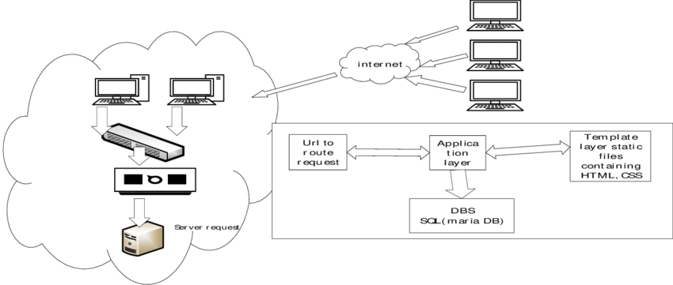

Figure 3.2: System Architecture

**3.6.3 Database Tables/Queries Structures**

## Table 3.1: Payment Table

|  |  |  |  |  |
| --- | --- | --- | --- | --- |
| **Field** | **Datatype (length)** | **Null** | **Key** | **Extra** |
| id | int(10) | NO | PRI | auto_increment |
| Student name | varchar(50) | YES |  |  |
| Student Email | varchar(50) | YES |  |  |
| Student Phone | varchar(50) | YES |  |  |
| Student Class | varchar(50) |  |  |  |
| Amount Paid | varchar(50) |  |  |  |
| Reference id | varchar(50) |  |  |  |
| Date | timestamp |  |  |  |

#### Table 3.2: Classes Table

|  |  |  |  |  |  |
| --- | --- | --- | --- | --- | --- |
| **Field** | **Type** | **Null** | **Key** | **Default** | **Extra** |
| id | int(10) | NO | PRI |  | auto_increment |
| classes | varchar(50) | YES |  |  |  |
| date_added | varchar(50) | YES |  |  |  |
| time_added | timestamp | YES |  | current_timestamp() |  |

#### Table 3.3: Administratives Table

|  |  |  |  |  |  |
| --- | --- | --- | --- | --- | --- |
| **Field** | **Type** | **Null** | **Key** | **Default** | **Extra** |
| id | int(10) | NO | PRI |  | auto_increment |
| school_name | varchar(255) | YES |  |  |  |
| school_motto | varchar(255) | YES |  |  |  |
| school_logo | varchar(255) | YES |  |  |  |
| school_stamp | varchar(255) | YES |  |  |  |
| upload_date | varchar(50) | YES |  |  |  |
| upload_time | timestamp | YES |  | current_timestamp() |  |

#### Table 3.4: Current Session Table

|  |  |  |  |  |  |
| --- | --- | --- | --- | --- | --- |
| **Field** | **Type** | **Null** | **Key** | **Default** | **Extra** |
| id | int(10) | NO | PRI |  | auto_increment |
| current_session | varchar(20) | YES |  |  |  |
| current_term | varchar(50) | YES |  |  |  |
| date_declared | varchar(50) | YES |  |  |  |
| time_declared | timestamp | YES |  | current_timestamp() |  |

#### Table 3.5: Result Table

|  |  |  |  |  |  |
| --- | --- | --- | --- | --- | --- |
| **Field** | **Type** | **Null** | **Key** | **Default** | **Extra** |
| id | int(10) | NO | PRI |  | auto_increment |
| class | varchar(10) | YES |  |  |  |
| term | varchar(50) | YES |  |  |  |
| session | varchar(50) | YES |  |  |  |
| reg_number | varchar(50) | YES |  |  |  |
| name | varchar(50) | YES |  |  |  |
| subjects | varchar(100) | YES |  |  |  |
| ca | int(10) | YES |  |  |  |
| project | int(10) | YES |  |  |  |
| exam | int(10) | YES |  |  |  |
| subject_total | int(10) | YES |  |  |  |
| subject_rank | int(10) | YES |  |  |  |
| date_of_upload | varchar(20) | YES |  |  |  |
| time_of_upload | timestamp | NO |  | current_timestamp() |  |

#### Table 3.6: Subjects

|  |  |  |  |  |  |
| --- | --- | --- | --- | --- | --- |
| **Field** | **Type** | **Null** | **Key** | **Default** | **Extra** |
| id | int(10) | NO | PRI |  | auto_increment |
| reg_number | varchar(100) | YES |  |  |  |
| name | varchar(100) | YES |  |  |  |
| class | varchar(20) | YES |  |  |  |
| subjects | varchar(100) | YES |  |  |  |
| term | varchar(50) | YES |  |  |  |
| session | varchar(50) | YES |  |  |  |
| registration_date | varchar(20) | YES |  |  |  |
| registration_time | timestamp | YES |  | current_timestamp() |  |

#### Table 3.7: Students

|  |  |  |  |  |  |
| --- | --- | --- | --- | --- | --- |
| **Field** | **Type** | **Null** | **Key** | **Default** | **Extra** |
| id | int(10) | NO | PRI |  | auto_increment |
| gender | varchar(20) | YES |  |  |  |
| firstname | varchar(50) | YES |  |  |  |
| lastname | varchar(50) | YES |  |  |  |
| othername | varchar(50) | YES |  |  |  |
| dob | varchar(50) | YES |  |  |  |
| mob | varchar(50) | YES |  |  |  |
| yob | varchar(50) | YES |  |  |  |
| contact_phone | varchar(20) | YES |  |  |  |
| address | text | YES |  |  |  |
| lga | varchar(255) | NO |  |  |  |
| state | varchar(50) | YES |  |  |  |
| nationality | varchar(50) | YES |  |  |  |
| sponsor_name | varchar(50) | YES |  |  |  |
| sponsor_phone | varchar(20) | YES |  |  |  |
| relationship | varchar(20) | YES |  |  |  |
| class | varchar(20) | YES |  |  |  |
| reg_number | varchar(100) | YES |  |  |  |
| gen_password | varchar(20) | YES |  |  |  |
| passport | varchar(255) | YES |  |  |  |
| date_of_reg | varchar(20) | YES |  |  |  |
| time_of_reg | timestamp | YES |  | current_timestamp() |  |

#### Table 3.8: Teachers

|  |  |  |  |  |  |
| --- | --- | --- | --- | --- | --- |
| **Field** | **Type** | **Null** | **Key** | **Default** | **Extra** |
| id | int(10) | NO | PRI |  | auto_increment |
| title | varchar(50) | YES |  |  |  |
| fullname | varchar(100) | YES |  |  |  |
| address | text | YES |  |  |  |
| phone | varchar(50) | YES |  |  |  |
| state | varchar(50) | YES |  |  |  |
| lga | text | YES |  |  |  |
| nationality | varchar(50) | YES |  |  |  |
| email | varchar(50) | YES |  |  |  |
| password | varchar(50) | YES |  |  |  |
| date_of_reg | varchar(50) | YES |  |  |  |
| time_of_reg | timestamp | YES |  | current_timestamp() |  |

#### Table 3.9: Users

|  |  |  |  |  |  |
| --- | --- | --- | --- | --- | --- |
| **Field** | **Type** | **Null** | **Key** | **Default** | **Extra** |
| id | int(10) | NO | PRI |  | auto_increment |
| title | varchar(50) | YES |  |  |  |
| fullname | varchar(100) | YES |  |  |  |
| address | text | YES |  |  |  |
| phone | varchar(50) | YES |  |  |  |
| state | varchar(50) | YES |  |  |  |
| lga | text | YES |  |  |  |
| nationality | varchar(50) | YES |  |  |  |
| email | varchar(50) | YES |  |  |  |
| password | varchar(50) | YES |  |  |  |
| date_of_reg | varchar(50) | YES |  |  |  |
| time_of_reg | timestamp | YES |  | current_timestamp() |  |

**3.6.4 Database Entity Relationship Diagram**

This shows the relationship of the various tables in the database with each other

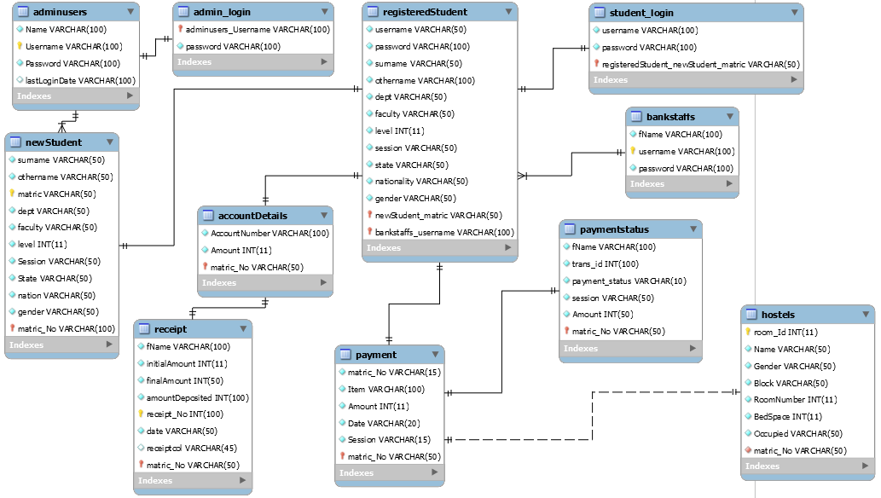

Figure 3.3: Database Entity Relationship Diagram

**3.6.5 The Input and Output Design**

Username or Registration Number

Enter Password

#### Don't Have an Account? [Create Account](http://localhost/school_dev/app.php#demanppopUpWindow)

Login

Figure 3.4: Login interface

CREATE PROFILE

Your Gender

User Type

First Name

Last Name

Phone Number

Email Address

Figure 3.5: Create Profile interface

**PAY WITH**

Card

Bank

Transfer

*# USSD

amir@yahoo.com

Pay **47,000.00**

Use the test bank account provided below to complete this payment

Zenith Bank

2203002930

**Verify Account**

Figure 3.6: Payment interface

Gender

First Name (Surname)

Last Name

Other Name (Optional)

Email

Phone Number

Home Address

State of Origin

LGA of Origin

Day

Month

Year

Sponsor Name

Phone Number

Target Class

Relationship

REGISTER

Figure 3.7: Complete Registration interface

**CONFIRM PAYMENT**

Reference code

Figure 3.8: Payment confirmation interface

# CHAPTER FOUR

# RESULTS AND DISCUSSION

## 4.1 Introduction

Explain your new system’s operation that leads to the results below.

## 4.2 Results

Welcome interface

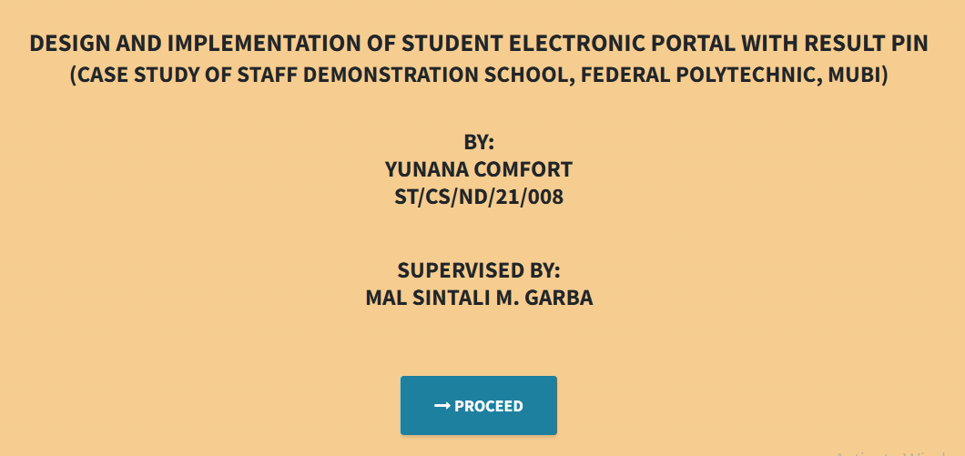

#### Figure 4.1: Welcome interface

Home page

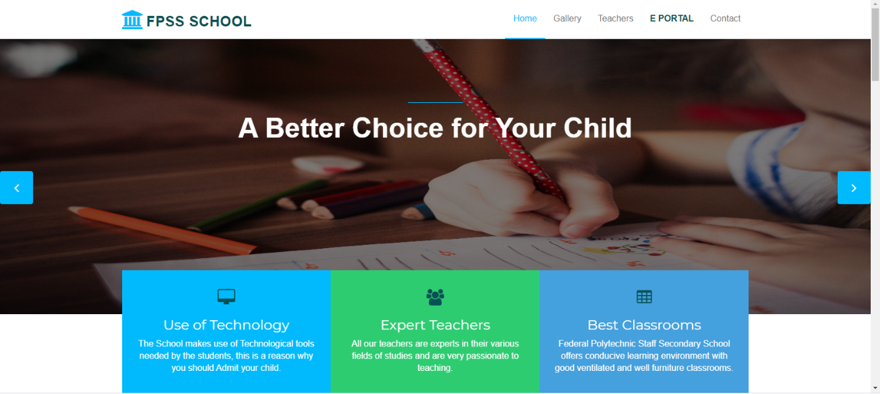

#### Figure 4.2: Home page interface

Login interface

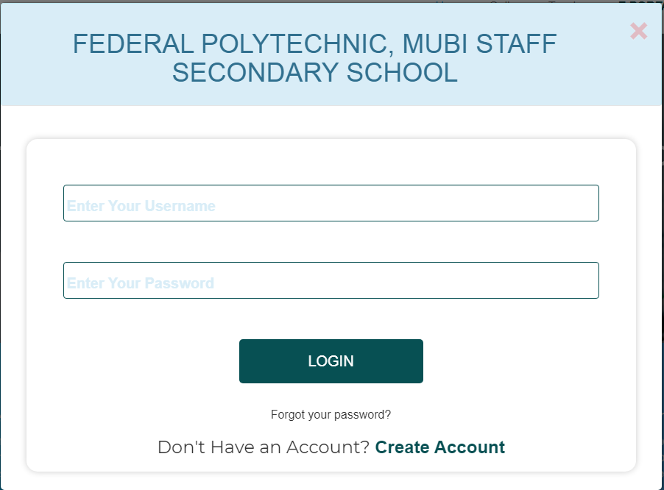

#### Figure 4.3: Login page interface

Signup interface

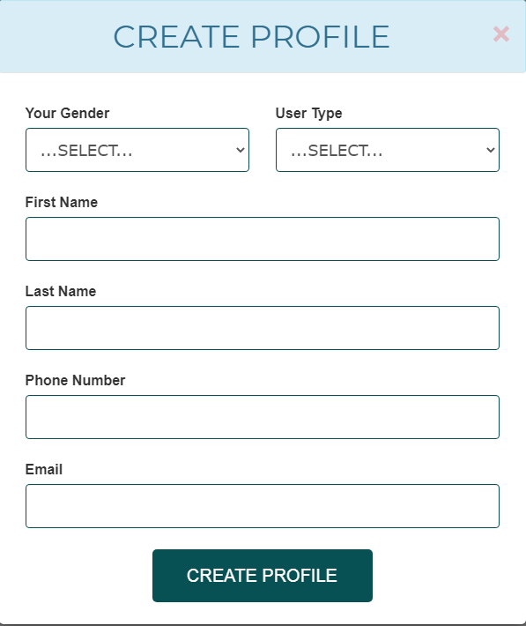

#### Figure 4.4: Signup page interface

Edit profile interface

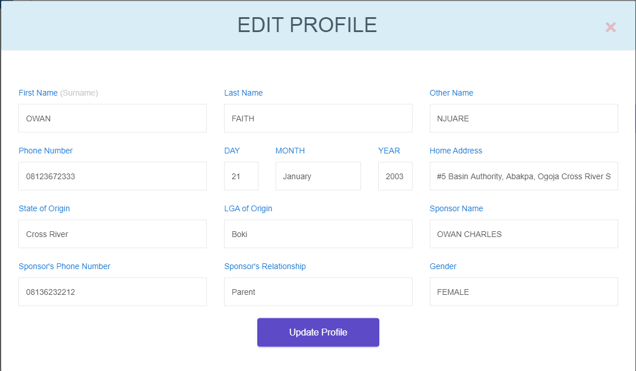

#### Figure 4.5: Edit profile page interface

Create announcement

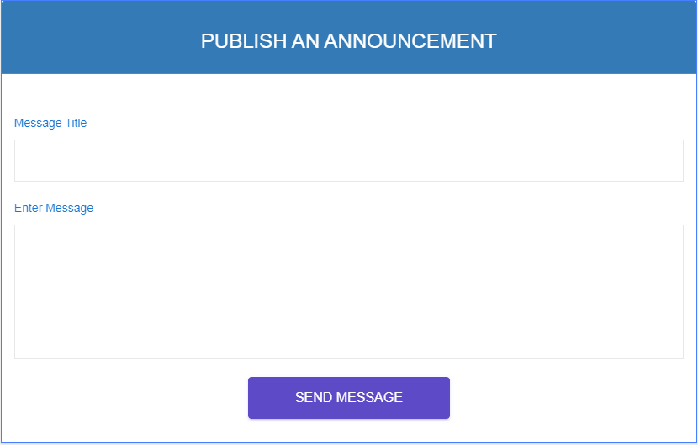

#### Figure 4.6: Create announcement interface

Announcement from Admin

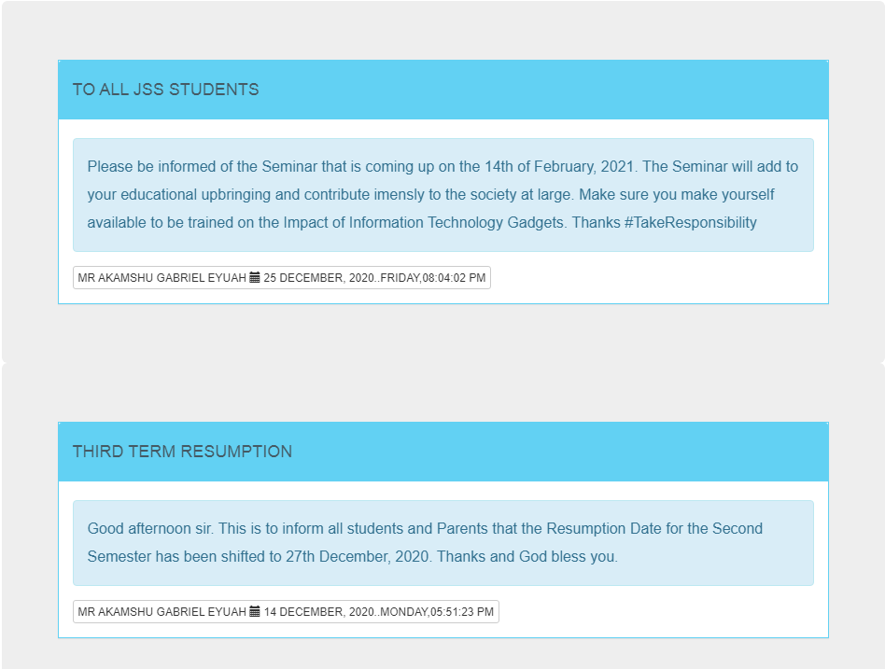

#### Figure 4.7: Announcement interface

Upload Result

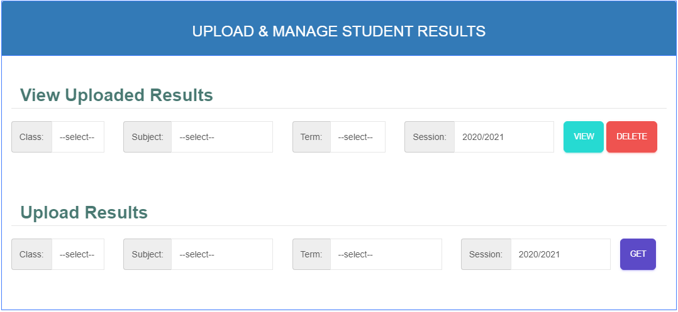

Figure 4.8: Upload result interface

Publish result

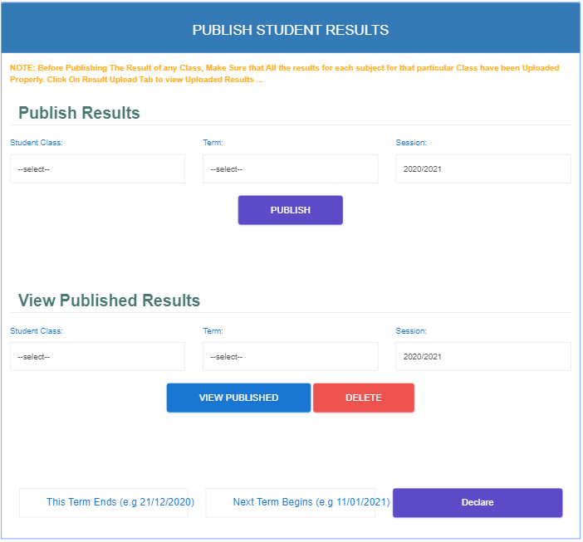

#### Figure 4.9: Publish result interface

Student registration slip

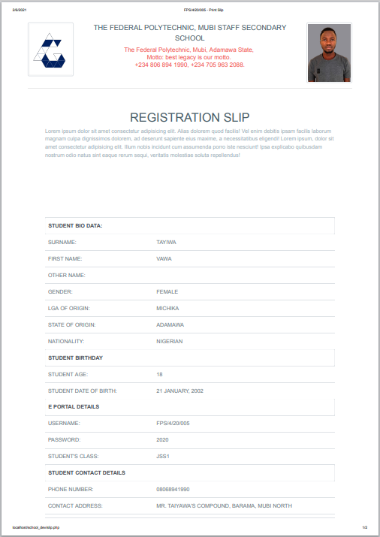

#### Figure 4.10: Student registration slip interface

Staff dashboard

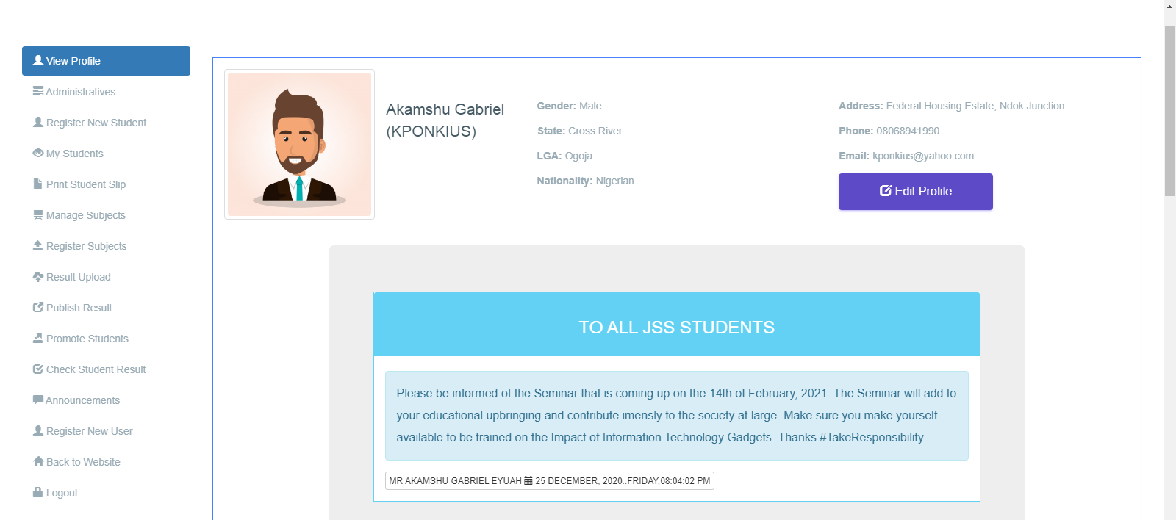

#### Figure 4.11: Staff dashboard interface

Student dashboard

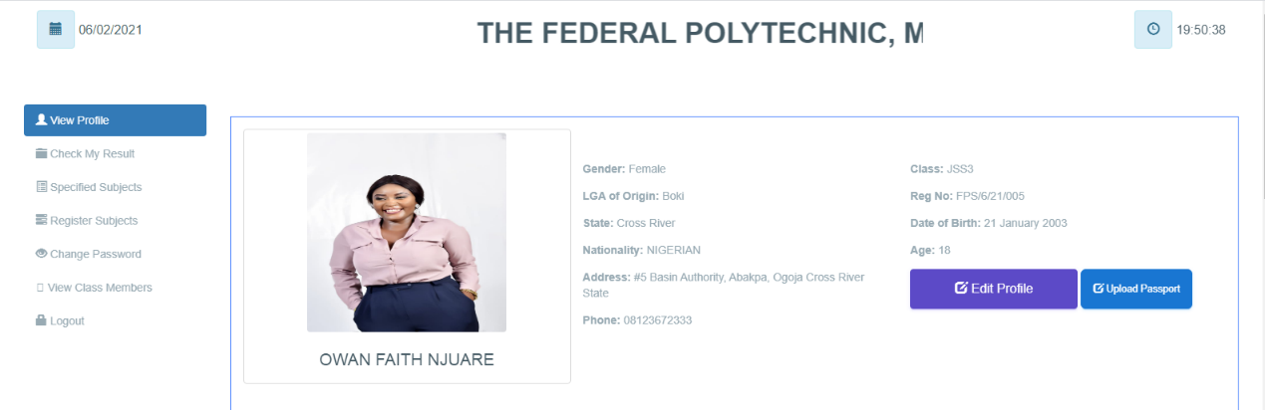

#### Figure 4.12: Student dashboard interface

## 

## 4.3 Discussion

**Welcome interface**

This is the very first interface which welcomes the user and shows the project topic, the designer and the supervisor of the project before proceeding to the main project.

**Home page**

This section displays the home page of the school portal where the user (student or staff) can go through the various facilities that the school has and where the login link for the portal is found as well.

**Login interface**

This section is used by an existing student or teacher to login into his or her account before completing any operation.

**Signup interface**

This is the signup page that allows the user to create an account with the school portal before he or she can complete any registration.

**Create announcement**

This section is used by the Admin (Principal) to pass information on the school portal to the students.

**Upload Result**

This section is used by the admin to upload results based on the data received from C.A. and exams marks appropriate for students on a particular subject. The admin (Principal) is allowed to upload result for all classes and subjects for all students.

**Publish result**

This section is only used by the admin to published all the various results that have been uploaded by the teachers or admin for result generation.

**Student registration slip**

This section is used to print the student registration slip that will be submitted to the school management and used to get the confirmation code from the management in order to generate a matric number.

**Staff or Student dashboard**

This is the admin dashboard that is used to display all the available operations that an admin, teacher or student can perform on the school the school portal.

## 4.4 User manual

The following are the necessary steps to take in order to use the system efficiently and effectively.

1. Load the url of the system <https://localhost/school_dev/> the welcome page will be displayed.
2. Click on the **Proceed** button to proceed to the main system.
3. Click on **E PORTAL** on the navigation bar to access the portal, the login interface will be displayed.
4. Click on the **Create Account** to create a profile account with the school portal.
5. Fill the form with your correct information to enable you create an account.
6. If you created an account, provide your login details by entering your username or Registration number and password.
7. Depending on the login details provided you will be automatically directed to the dashboard.
8. The various task that you can perform on the portal will be displayed on the sidebar of the dashboard.

# CHAPTER FIVE

# SUMMARY, CONCLUSION AND RECOMMENDATION

## 5.1 Summary

The new system was designed in such a way that records about of the student that of Federal Polytechnic, Mubi Staff Secondary school will be stored in a database for easy retrieval and manipulation of data that can be accessible from any place reducing the overcrowding in the management office for registration. The new system will also help the school to generate funds through the sale of Scratch cards.

## 5.2 Conclusion

The student Eportal was designed and implemented, the aim and specific objectives of the project were achieved successfully.

## 5.3 Recommendations

The researcher puts forward the following recommendations:

1. The school management should imbibe the use of this technology in carrying out her tasks in order to reduce the time wastage that is involved with the manual system.
2. The researcher also recommends that the system be put to effective use in order to derive the necessary efficiency of the system.

## 5.4 Contribution to Knowledge

The new system was designed in a structured and robust way employing responsive design to it to ensure usability and efficiency. The project research will serve as a reference point for other research work and contribute immensely to knowledge for those conducting a research on similar topic.

## 5.5 Area for further work

The research work limited in making online payment. Therefore, the researcher suggests that further studies be conducted to include the payment of fees online.

# REFERENCES

Abuhamdieh, H. & Sehwail, L. (2017). A comparative study of campus portal user acceptance: Student and faculty perspectives Journal of STEM Education, 8(34), 40-49.

Adepoju, S. & Osofisan, O. (2018). Website usability: A comparison of three universities websites. Journal of Science, Technology and Mathematics Education, 1(1), 114-121.

Astani, M. & Elhindi, M. (2018). An empirical study of university websites. Journal of Information Systems, 10(2), 460-465.

Allan, H. (2014). Measuring campus portal effectiveness and the contributing factors. Campus-Wide Journal of Information Systems, 24(5), 342-354. doi:10.1108/10650740710835760.

Babbie, E. (2014). The Practice of Social Research. Belmont, CA: Thomson/Wadsworth.

Brayand, G. (2014). The impact of website portals: research synthesis. Journal of Information Systems, 16(1), 7-30. doi:10.2308/jis.2002.16.1.7

Boye, M. (2015). Educational Portals: A way to get integrated, user-centric university information systems. International journal of information services, 8(1), 17-23.

Bringula, R., & Basa, S. (2016). Factors affecting faculty web porta! usability. Journal of Educational Technology & Society, 14 (4), 253-265.

Cappel, J. & Huang, Z. (2017). A usability analysis of company websites. Journal of Computer Information Systems, 48(1), 117-123.

Chen, S., Li, S. & Li, C. (2014). Recent related research in technology acceptance model: A literature reviews Australian Journal of Business and Management Research, 1(9), 124-127.

Davis, F. (2019). Perceived usefulness, perceived ease of use, and user acceptance of information technology. Journal of Management Information System, 13(3), 319-340.

Doll, J. & Torkzadeh, A. (1988). White paper eleven enterprise web customer case studies: Plumtree Software, San Francisco, CA

Fuangvut, J. & Hasan, D. (2015). Begin with the end (user) in mind: Planning for the San Diego State University campus portal. In Jafari, A., & Sheehan, M. (Eds.), Designing Portals: Opportunities and Challenges (127-161). PA: Hershey.

Gerd, J. (2015). Measuring campus portal effectiveness and the contributing factors. Campus-Wide Journal of Information Systems, 24(5), 342-354. doi:10.1108/10650740710835760.

Hasan, H. (2013). Accommodating inter-generational stakeholders in a campus portal. Retrieved January 11, 2020, from <http://www.iseing.org/emcis/EMCIS2005/pdfs/22.pdf>

Hasan, L. (2013). Using university ranking systems to predict usability of university websites. Journal of Information Systems and Technology Management, 10(2), 235 250 DOI: 10.4301/S1807-17752013000200003 ISO 9241-11 (1998).

Ives, B. (2013). The measurement of user information satisfaction. Journal of communication, 26(10), 785-793. doi:10.1145/358413.358430

Lim, H. (2014). Cross cultural differences in online learning motivation. Paper presented at the Academy of Human Resources Development International Conference. Retrieved November 27, 2020 from http;//www.editlib.org/p/59841.

Lim, K. (2014). The role of corporate portal on consolidating an organization’s internal and external information and knowledge repositories. Retrieved February 12, 2020 from http:/Avww.bing.com/search?q=Full+Text+Mobile+PDF&src=IE-SearchBox&FORM=IE8SRC

Mahmood, M., Burn, J., Gemoets, L., & Jacquez, C. (2010). Variables affecting information technology end-user satisfaction: A meta-analysis of the empirical literature. International Journal of Human-Computer Studies, 52(5), 751-771. doi:10.1006/ijhc.1999.0353.

Masrek, N. (2017). Measuring campus portal effectiveness and the contributing factors. Campus-Wide Journal of Information Systems, 24(5), 342-354. doi:10.1108/10650740710835760.

McKinney, V., Yoon, K., & Zahedi, F. (2012). The measurement of web-customer satisfaction: An expectation and disconfirmation approach. Journal of Information System Research, 13(3), 296-315.

Mentes, S. & Turan, H. (2012). Assessing the usability of university websites: An emipirical study on Namik Kemal University. Turkish Online Journal of Educational Technology, 2 (3), 61-69.

Moskowitz, R. (2011). Campus portals: Come to higher education. Matrix: The Magazine for Leaders in Higher Education, 2(3), 54(3).

Okene, F. & Enukpere, V. (2011). Comparative analysis of the usability of academic websites of Delta State Polytechnics. Journal of Emerging Trends in Engineering and Applied Sciences, 2(6), 1042-1046.

Olalekan, A. & Adepoju, T. (2012). Usability study of some selected functional websites in Nigeria. African Journal of Computing & Information Communication Technology, 5 (3), 57-70.

Ovem, J. (2015). Designing Portals: Opportunities and Challenges. Hershey, PA: Information Science Publishing, New Jersey.

Pierce, K. (2015). Web site usability report for Harvard University. Retrieved 24" November, 2020 from <http://digitalcommons.utep.edu/cgi/viewcontent.ogi?>

Pierece, A. (2015). An Overview of corporate portal technology and development: Survey results from organizations that have deployed corporate portal. Retrieved July 8, 2020 from <http://www.plumtree.com/pdf/>

Rai, A. (2012). Assessing the validity of IS success models: An empirical test and theoretical analysis. Information Systems Research Journal, 13(1), 50-69. doi:10.1287/isre.13.1. 50. 96

Rao, S. (2013). Distance education and the role of IT in India. The Electronic Library, 24(3), 225-236. doi:10.1108/026404706 10660396

Reus, A. (2013). Assessing the validity of IS success models: An empirical test and theoretical analysis. Information Systems Research Journal, 13(1), 50-69. doi:10.1287/isre.13.1.50.96

Richard, V. (2016). Returns on investments in information technology: A research synthesis. Journal of Information Systems, 16(1), 7-30. doi:10.2308/jis.2002.16.1.7

Roberts-Witt, S. (2019). User satisfaction with business-to-employee _ portals: Conceptualization and scale development. European Journal of Information Systems, 17(6), 649-667. doi:10.1057/ejis.2008.55

Sharma, S. & Gupta, J. (2015). Web portals: The new gateways to Internet information and services. Idea Group Publishing: Hershey

Sugianto, L., & Tojib, D. R. (2017). Facilitating Employees with B2E Portal. In Proceedings of the 7" International Research Conference on Quality Innovation and Knowledge Management (pp. 553-560).

Tella, A. & Bashorun, T. (2012). Undergraduate students’ satisfaction with the use of web portals. International Journal of Web Portals 4(2), 52-73. DOI: 10.4018/jwp.2012040104h

Tojib, S. (2018). A conceptual model for B2E portal model satisfaction. Retrieved May 12, 2020 from <https://bai2006.atisr.org/CD/Papers/2006bai6315.doc>

Worjtkowski, W. & Major, M. (2015). Online portals: The new gateways to Internet information and services. Idea Group Publishing: Hershey

Zaphiris, P. & Ellis, D. (2013). Website usability and content accessibility of the top USA universities. Retrieved February 4, 2021 from <http://pzaphiri.agrino.org/Papers/accessibilitywebnet.pdf>

# APPENDIX A

Welcome interface



Home page



Login interface



Signup interface



Edit profile interface



Create announcement



Announcement from Admin



Upload Result



Publish result



Student registration slip



Staff dashboard



Student dashboard



# APPENDIX B

**PROGRAM CODE**

|  |  |
| --- | --- |
|  |  |
|  |  |
|  |  |
|  | <!DOCTYPE html> |
|  | <html lang="en"> |
|  | <head> |
|  | <meta charset="utf-8"> |
|  | <meta http-equiv="X-UA-Compatible" content="IE=edge"> |
|  | <meta name="viewport" content="width=device-width, initial-scale=1"> |
|  | <title>FPS Secondary School | Home</title> |
|  |  |
|  | <!-- Favicon --> |
|  | <link rel="shortcut icon" href="[assets/img/favicon.ico](http://localhost/school_dev/assets/img/favicon.ico)" type="image/x-icon"> |
|  |  |
|  | <!-- Font awesome --> |
|  | <link href="[assets/css/font-awesome.css](http://localhost/school_dev/assets/css/font-awesome.css)" rel="stylesheet"> |
|  |  |
|  |  |
|  | <!-- Bootstrap --> |
|  | <link href="[assets/css/bootstrap.css](http://localhost/school_dev/assets/css/bootstrap.css)" rel="stylesheet"> |
|  | <!-- Slick slider --> |
|  | <link rel="stylesheet" type="text/css" href="[assets/css/slick.css](http://localhost/school_dev/assets/css/slick.css)"> |
|  | <!-- Fancybox slider --> |
|  | <link rel="stylesheet" href="[assets/css/jquery.fancybox.css](http://localhost/school_dev/assets/css/jquery.fancybox.css)" type="text/css" media="screen" /> |
|  | <!-- Theme color --> |
|  | <link id="switcher" href="[assets/css/theme-color/default-theme.css](http://localhost/school_dev/assets/css/theme-color/default-theme.css)" rel="stylesheet"> |
|  |  |
|  | <!-- Main style sheet --> |
|  | <link href="[assets/css/style.css](http://localhost/school_dev/assets/css/style.css)" rel="stylesheet"> |
|  | <link rel="stylesheet" href="[popup_style.css](http://localhost/school_dev/popup_style.css)"> |
|  |  |
|  | <!-- Google Fonts --> |
|  | <link href='<https://fonts.googleapis.com/css?family=Montserrat:400,700>' rel='stylesheet' type='text/css'> |
|  | <link href='<https://fonts.googleapis.com/css?family=Roboto:400,400italic,300,300italic,500,700>' rel='stylesheet' type='text/css'> |
|  |  |
|  |  |
|  | </head> |
|  | <body> |
|  |  |
|  |  |
|  |  |
|  |  |
|  | <!--START SCROLL TOP BUTTON --> |
|  | <a class="scrollToTop" href="[#](http://localhost/school_dev/app.php)"> |
|  | <i class="fa fa-angle-up"></i> |
|  | </a> |
|  | <!-- END SCROLL TOP BUTTON --> |
|  |  |
|  | <!-- LOADER --> |
|  | <div id="preloader"> |
|  | <div class="loader-container"> |
|  | <div class="progress-br float shadow"> |
|  | <div class="progress__item"></div> |
|  | </div> |
|  | </div> |
|  | </div> |
|  | <!-- END LOADER --> |
|  |  |
|  | <!-- Start menu --> |
|  | <section id="mu-menu"> |
|  | <nav class="navbar navbar-default" role="navigation"> |
|  | <div class="container"> |
|  | <div class="navbar-header"> |
|  | <!-- FOR MOBILE VIEW COLLAPSED BUTTON --> |
|  | <button type="button" class="navbar-toggle collapsed" data-toggle="collapse" data-target="#navbar" aria-expanded="false" aria-controls="navbar"> |
|  | <span class="sr-only">Toggle navigation</span> |
|  | <span class="icon-bar"></span> |
|  | <span class="icon-bar"></span> |
|  | <span class="icon-bar"></span> |
|  | </button> |
|  | <!-- LOGO --> |
|  | <!-- TEXT BASED LOGO --> |
|  | <a class="navbar-brand" href="[index.html](http://localhost/school_dev/index.html)"><i class="fa fa-university"></i><span>FPSS School</span></a> |
|  | <!-- IMG BASED LOGO --> |
|  | <!-- <a class="navbar-brand" href="index.html"><img src="assets/img/logo.png" alt="logo"></a> --> |
|  | </div> |
|  | <div id="navbar" class="navbar-collapse collapse"> |
|  | <ul id="top-menu" class="nav navbar-nav navbar-right main-nav"> |
|  | <li class="active"><a href="[index.html](http://localhost/school_dev/index.html)">Home</a></li> |
|  | <li><a href="[#mu-gallery](http://localhost/school_dev/app.php#mu-gallery)">Gallery</a></li> |
|  | <li class="nav-item"><a class="nav-link" href="[#mu-latest-courses](http://localhost/school_dev/app.php#mu-latest-courses)">Teachers</a></li> |
|  | <li><a class="hover-btn-new log orange" href="[#login](http://localhost/school_dev/app.php#login)" |
|  | data-toggle="modal" data-target="#login"><span>E PORTAL</span></a></li> |
|  | <li><a href="[#](http://localhost/school_dev/app.php)">Contact</a></li> |
|  | <li></li> |
|  | </ul> |
|  | </div><!--/.nav-collapse --> |
|  | </div> |
|  | </nav> |
|  | </section> |
|  | <!-- End menu --> |
|  | <!-- Start search box --> |
|  | <div id="mu-search"> |
|  | <div class="mu-search-area"> |
|  | <button class="mu-search-close"><span class="fa fa-close"></span></button> |
|  | <div class="container"> |
|  | <div class="row"> |
|  | <div class="col-md-12"> |
|  | <form class="mu-search-form"> |
|  | <input type="search" placeholder="Type Your Keyword(s) & Hit Enter"> |
|  | </form> |
|  | </div> |
|  | </div> |
|  | </div> |
|  | </div> |
|  | </div> |
|  | <!-- End search box --> |
|  |  |
|  |  |
|  |  |
|  |  |
|  |  |
|  | <!-- Modal --> |
|  | <div data-backdrop='static' class="modal fade" id="login" tabindex="-1" role="dialog" aria-labelledby="myModalLabel"> |
|  | <div class="modal-dialog modal-dialog-centered modal-md" role="document"> |
|  | <div class="modal-content"> |
|  | <div class="modal-header tit-up alert alert-info"> |
|  | <button type="button" class="close" style='color:red; font-size:50px;' data-dismiss="modal" aria-hidden="true">&times;</button> |
|  | <h1 class='h1 text-center' style='text-transform:uppercase; max-width:95%;'>Federal Polytechnic, Mubi Staff Secondary School</h1> |
|  | </div> |
|  |  |
|  | <div class="modal-body"> |
|  | <!-- <h1 style='text-align:center;'>LOGIN TO YOUR ACCOUNT</h1> --> |
|  | <div class="inner" id="Login" > |
|  | <form autocomplete="autocomplete_off_kponk" method='POST' action="/school_dev/app.php" > |
|  | <br> |
|  | <!-- <input name='hidden' class="form-control" id="" placeholder=" " type="text" autocomplete='false' style='display:none;'> --> |
|  |  |
|  | <label class="form-group" for="email1"> |
|  | <input name='login_id' class="form-control" id="email1" placeholder=" " type="text" autocomplete="off_kponk" required> |
|  | <span>Enter Your Username </span> |
|  | <span class='border'></span> |
|  | </label> |
|  |  |
|  | <label class="form-group" for="exampleInputPassword1"> |
|  | <input class="form-control" id="exampleInputPassword1" placeholder=" " name="login_password" type="password" autocomplete='kponk_off' required> |
|  | <span>Enter Your Password</span> |
|  | <span class='border'></span> |
|  | </label> |
|  | <div class="row text-center"> |
|  | <p class='text-center'><input type="submit" name="login_btn" class="" value="LOGIN"></p> |
|  |  |
|  | <p lass="text-center" ><a href="javascript:;">Forgot your password?</a></p> |
|  | <h4> Don't Have an Account? <a href="[#demanppopUpWindow](http://localhost/school_dev/app.php#demanppopUpWindow)" data-toggle="modal" data-target="#demanppopUpWindow" data-dismiss="modal" > <span>Create Account</span></a> </h4> |
|  | </div> |
|  | </form> |
|  | </div> |
|  | </div> |
|  | </div> |
|  | </div> |
|  | </div> |
|  |  |
|  |  |
|  | <!-- Start Slider --> |
|  | <section id="mu-slider"> |
|  | <!-- Start single slider item --> |
|  | <div class="mu-slider-single"> |
|  | <div class="mu-slider-img"> |
|  | <figure> |
|  | <img src="[assets/img/slider/4.jpg](http://localhost/school_dev/assets/img/slider/4.jpg)" alt="img"> |
|  | </figure> |
|  | </div> |
|  | <div class="mu-slider-content"> |
|  | <span></span> |
|  | <h2>We Will Help Your Child/Ward To Learn</h2> |
|  | </div> |
|  | </div> |
|  | <!-- Start single slider item --> |
|  | <!-- Start single slider item --> |
|  | <div class="mu-slider-single"> |
|  | <div class="mu-slider-img"> |
|  | <figure> |
|  | <img src="[assets/img/slider/8.jpg](http://localhost/school_dev/assets/img/slider/8.jpg)" alt="img"> |
|  | </figure> |
|  | </div> |
|  | <div class="mu-slider-content"> |
|  | <span></span> |
|  | <h2>A Better Choice for Your Child</h2> |
|  |  |
|  | </div> |
|  | </div> |
|  | <!-- Start single slider item --> |
|  | <!-- Start single slider item --> |
|  | <div class="mu-slider-single"> |
|  | <div class="mu-slider-img"> |
|  | <figure> |
|  | <img src="[assets/img/slider/9.jpg](http://localhost/school_dev/assets/img/slider/9.jpg)" alt="img"> |
|  | </figure> |
|  | </div> |
|  | <div class="mu-slider-content"> |
|  | <span></span> |
|  | <h2>"Train up a child in the way he should grow"</h2> |
|  |  |
|  | </div> |
|  | </div> |
|  | <!-- Start single slider item --> |
|  | <!-- Start single slider item --> |
|  | <div class="mu-slider-single"> |
|  | <div class="mu-slider-img"> |
|  | <figure> |
|  | <img src="[assets/img/slider/10.jpg](http://localhost/school_dev/assets/img/slider/10.jpg)" alt="img"> |
|  | </figure> |
|  | </div> |
|  | <div class="mu-slider-content"> |
|  | <span></span> |
|  | <h2>Five Times Award for Best Secondary School</h2> |
|  | </div> |
|  | </div> |
|  | <!-- Start single slider item --> |
|  | <!-- Start single slider item --> |
|  | <div class="mu-slider-single"> |
|  | <div class="mu-slider-img"> |
|  | <figure> |
|  |  |
|  |  |
|  |  |
|  | <!-- jQuery library --> |
|  | <script src="[assets/js/jquery.min.js](http://localhost/school_dev/assets/js/jquery.min.js)"></script> |
|  | <!-- Include all compiled plugins (below), or include individual files as needed --> |
|  | <script src="[assets/js/bootstrap.js](http://localhost/school_dev/assets/js/bootstrap.js)"></script> |
|  | <!-- Slick slider --> |
|  | <script type="text/javascript" src="[assets/js/slick.js](http://localhost/school_dev/assets/js/slick.js)"></script> |
|  | <!-- Counter --> |
|  | <script type="text/javascript" src="[assets/js/waypoints.js](http://localhost/school_dev/assets/js/waypoints.js)"></script> |
|  | <script type="text/javascript" src="[assets/js/jquery.counterup.js](http://localhost/school_dev/assets/js/jquery.counterup.js)"></script> |
|  | <!-- Mixit slider --> |
|  | <script type="text/javascript" src="[assets/js/jquery.mixitup.js](http://localhost/school_dev/assets/js/jquery.mixitup.js)"></script> |
|  | <!-- Add fancyBox --> |
|  | <script type="text/javascript" src="[assets/js/jquery.fancybox.pack.js](http://localhost/school_dev/assets/js/jquery.fancybox.pack.js)"></script> |
|  |  |
|  | <script> |
|  |  |
|  |  |
|  | function isInputNumber(evt) { |
|  | let char = String.fromCharCode (evt.which); |
|  | if(!(/[0-9]/.test(char))){ |
|  | evt.preventDefault(); |
|  | } |
|  |  |
|  | } |
|  | </script> |
|  | <!-- Custom js --> |
|  | <script src="[assets/js/custom.js](http://localhost/school_dev/assets/js/custom.js)"></script> |
|  |  |
|  | </body> |
|  | </html> |